Guidance for Completing Risk Register

Column | Explanation
Risk ID | Assign a unique identifier to each risk. This helps track and reference risks across reports and updates.
Risk Description | Provide a brief description of the risk
Risk Category | Select the appropriate category from the dropdown. This helps organize and prioritize risks.
Likelihood (Probability) | Choose the likelihood of the risk occurring from the dropdown. This helps in assessing the risk’s probability.
Impact | Choose the potential impact on the organization from the dropdown. Assess the business impact in operational terms.
Risk Rating | This is automatically calculated based on the selected Likelihood and Impact. This rating prioritizes risks for further action.
Mitigation Measures | Document the actions or controls that will reduce or eliminate the risk. Ensure each risk has an appropriate action.
Risk Owner | Assign the person or team responsible for managing this risk. The risk owner is accountable for implementing mitigation measures.

Status | Select the current state of the risk from the dropdown. Update this field regularly.
Review Date | Set a specific date for reviewing the risk. This ensures that mitigation measures are working, or if necessary, additional actions are required.

Dropdown Menus

- Risk Category:
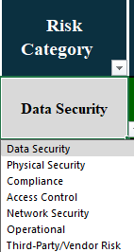

- Likelihood (Probability):
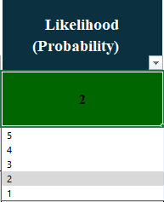

- Impact (Business Impact):

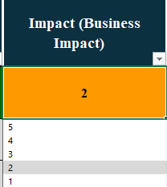

- Status
